Get in Shape

Many people want to get in shape and improve their health but have a difficult time maintaining a regimen that works for them. These simple steps will help you start a workout program that can work for you and enable you to continue. When you don't feel like making it to the gym, exercise on your own.

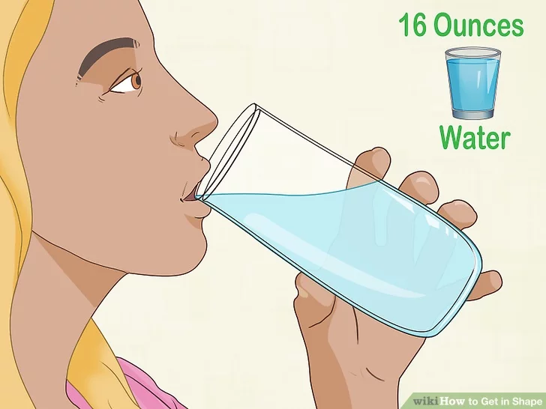

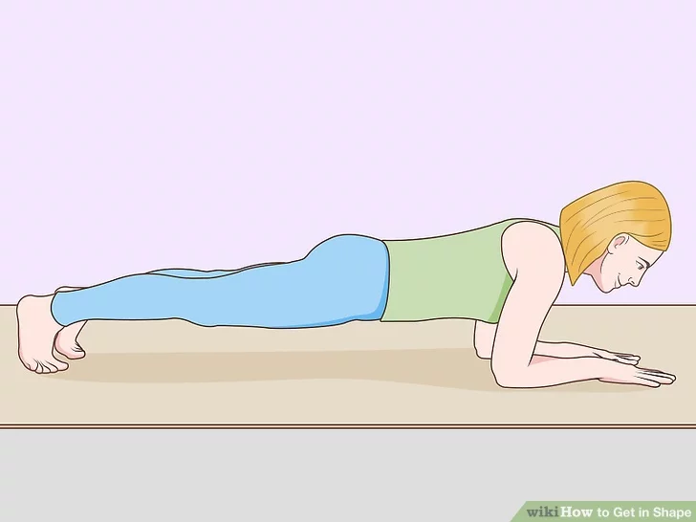

Eating well can Improve much for being a Fit Individual

Create a calorie deficit. To lose weight while getting in shape, you will need to create a calorie shortfall. This means that you will eat fewer calories than are needed to maintain your weight, causing your body to begin burning fat. Calculate how many calories you need to maintain your weight and then plan how many calories you can eat in a day (usually 2,000 calories a day)

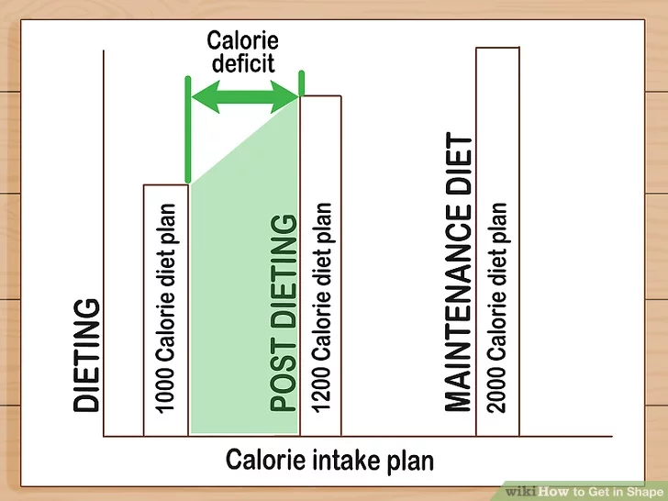

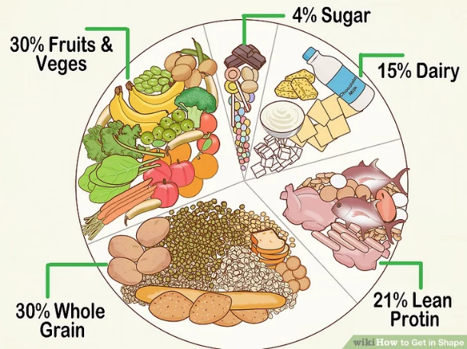

Get active. If you must sit at school and/or work, then move your legs and body about, but not constantly like a pendulum. Get up and go to the pencil sharpener, if possible. Step outside during your lunch break or walk to get a drink of water. If you want to get in shape but you’re too busy to hit the gym, you need to at least get yourself up and active. Walk. Park on the far side of the parking area. There are lots of ways to do such things, and they don’t need to be very time consuming or costly at all.
- Make a point of taking the stairs rather than an elevator when going home or to work (split between stairs and elevator if you need to go up very high).
- Get a standing or treadmill desk, or use an exercise ball instead of a desk chair. Go ahead, listen to your favourite TV shows -- but don’t just sit there watching. Cook, fold laundry, empty the dishwasher or ride a stationary bike. Do a step routine/step up/step down (repeatedly) for a good while.
- Do squats while waiting for your food to cook. Walk around on your tiptoes, in a duck posture or in a semi-squatting position.

Be consistent! If you want to get in shape, you will need to get in some activity at least every other day. You can’t expect results when you exercise inconsistently and infrequently. Have a plan and follow it.
- Don't try to work out every day of the week. You should have at least 2 or 3 rest days total per week. Give your body time to rest and build muscle! Your resting time is essential.

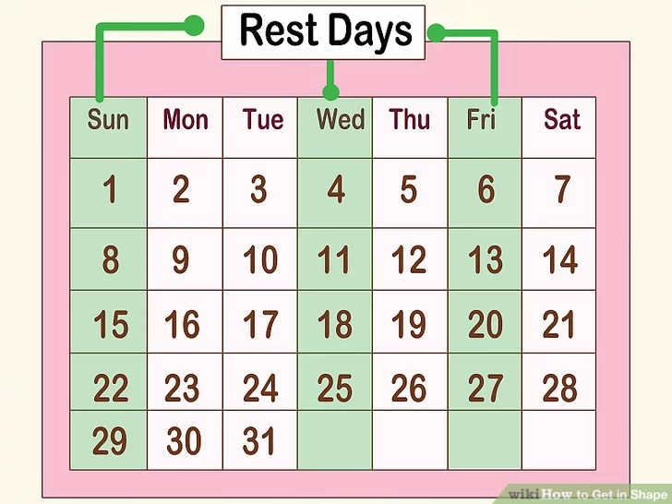

Benefits of getting our body Fit
- Reduces cholesterols
- Sleep Better
- Reduces Blood pressure
- Decrease Back pain
- Improves Self esteem
- Reduces risk Injuries
- Prevent Certain Cancer
- Increase Metabolic rate

